Installing Windows 10 on Hyper-V Virtual Machine

Name
Institution of Affiliation
Professor
Date

Installing Windows 10 on Hyper-V Virtual Machine
Table of contents
1.0 Introduction………………………………………………………………………………….
1.1 Purpose………………………………………………………………………………………
1.2 Intended Audience…………………………………………………………………………
1.3 Scope……………………………………………………………………………………….
1.4 Organization Description………………………………………………………………………
1.5 Conventions ……………………………………………………………………………………
1.6 Motivation …………………………………………………………………………………….
1.7 Safety and Disclaimers…………………………………………………………………………
2.0 Description of the Equipment………………………………………………………………….
2.1 Illustration of the Equipment…………………………………………………………………..
2.2 Description of the Equipment's Parts…………………………………………………………
3.0 List of Materials and Equipment Needed. ……………………………………………………..
3.1 Illustration of the Parts Needed to Carry Out the Instructions ………………………………...
3.2 Tools needed ……………………………………………………………………………….
3.3 Table of the parts with description of each……………………………………………………
4.0 Directions……………………………………………………………………………………
4.1 The Task These Directions Are Designed to Show…………………………………………
5.0 Troubleshooting……………………………………………………………………………...
6.0 Glossary……………………………………………………………………………………...
7.0 Reference List…………………………………………………………………………………

- Introduction
Hyper-V virtual machine allows user's install multiple operating systems on windows. In this guide we will learn on how to install windows 10 operating system on Hyper-V virtual machine. This will equip the participants with the skills needed to work with the Hyper-V installations.

  - Purpose
This training manual focuses on showing step by step instruction on installing Windows 10 on Hyper-V Virtual Machine. Coming up with a team of skillful personnel in the installation of windows 10 and any other installations of operating system's distributions will be well outlined in this manual.
  - Intended Audience
This guide is meant for software developers, technology enthusiasts, information technology professionals, students in computer-related courses. All the technology enthusiasts must go through the manuals to be able to know the pros and cons of Hyper-V installation of windows 10 via virtual machines.
  - Scope
Hyper-V technology can create virtual machines on both the 86-bit and 64-bit processors.Hyper-V installation of windows 10 operating system allows the creation of a virtualized server platform using the Hyper-V technology. This allows the technology savvy to optimally use his or her hardware resources. Hyper-V virtualizes software both the operating systems and all the physical components, for instance, the memory, storage, and network connectivity of the windows system.

  - Organization Description
Technology has grown widely, and each day as developers in the field of Information and technology has embraced the technology advancements. Amongst the advancement is the installation of the operating system on virtual machines. This has greatly enabled our IT organization to steer forward the process of helping the majority to familiarize and operate with various operating systems installed on the machines via the Hyper-V virtual box. These installation tasks initiated the training of the participants who are to work with a different machine environment without performing the clean installation on their machine. This task will enable IT, enthusiasts in the organization to switch between different operating systems with ease. With regard to this technological ability, the windows 10 installation on Hyper-V is an achievement to the tech participants wishing to toggle between operating systems in their current operating system they are working with.
  - Conventions
This installation needs several conventions to reach its success, from hardware requirements for running the Hyper -V to software requirement. The hardware conventions required are the CPU with several technologies as well. That is NX bit .X86-64. The task as well requires at least 2GB of memory and any other storage that needs each on the guest machine. Hyper-V virtual machines operate directly with the server in the machine's hardware; thus, the task involves hardware-assisted virtualization (either VT-x or AMD-V).
  - Motivation
The urge to venture and to steer forward the growth of a large team of experts who are aware of the technical know-how of the operating system and the various distributions of the OS emerging in the market. This will serve the technology savvies to be aware of the installation and use of the OS distributions via the Virtual box.

  - Safety and Disclaimers
Hyper -V is regarded as the Microsoft virtual machine tool. It is recommended to the machines that run multiple operating systems for it to be enabled or allowed. On this task, one is required not to install any unrequired software on the management operating system. For safety purposes, if one will need software, he or she should install them on virtual machines that run on the Hyper-V host.
- Description of the Equipment
Hyper-V is available in various windows distributions, including windows 10 pro, Enterprise, and Education in 64-Bit version. It also requires the Second level address (SLA) translation in the latest 64-bit processors of windows 10.
  - Illustration of the Equipment
Hyper-V can be operated on the following operating system requirement, namely windows 10 pro, enterprise, and education versions. These are amongst the operating system requirements of the Hyper-V before putting into consideration its installation procedures. Windows 10 home, mobile, and mobile enterprise versions cannot allow the installation of Hyper-V.

  - Description of the Equipment's Parts

Processor
This is the vital part of the machine required by the Hyper-V, and it must be of the 64-bit processor with second-level Address Translation.
Central processing unit
Hyper-V task requires additional CPU support for virtual machine monitor Mode (VT-x on intel Central processing unit).
4GB Memory
Virtual machine shares memory with the Hyper-V host; therefore, one is requested to have enough memory to accommodate the workload to be done virtually. The minimum space needed is 4GB of the memory space.
System BIOS
Virtualization technology and the hardware-enforced data execution prevention should be enabled either through the command prompt or through the motherboard settings accessed when rebooted.

- List of Materials and Equipment Needed.
The materials that could be employed are free Hyper-V management tools, web interface for Hyper-V, coreconfig 2.0, a free management tool for virtual machine configuration Hyper-V system compatibility check, FreeBSD support on Hyper-V, Hyper-V command-line tools, and Hype-V performance monitor.
Other equipments required are Hyper-V security tutorials, Hyper-V WMI tutorials. He was inspecting through the site that explains more about virtualization.
  - Illustration of the Parts Needed to Carry Out the Instructions
free Hyper-V management utility.
this entails all the utilities that ease the management of Hyper-V; this part is a free and full-featured tool in windows 10 operating systems that is Hyper-V enabled only,
Hyper-V command-line interface
These are vital applications that will grant one easy setting of the state of a virtual machine directly from the console.
The console will allow one to start, shutdown, reboot, reset force shutdown, or powering off the Hyper-V (Hong C,2017).

Hype-V performance monitor
This majorly focuses on the monitoring requirements. It was designed to inspect vital parameters of the Hyper-V Microsoft platform. This reveals the resources with their detailed utilization Information of the virtual machine server. These include; how the CPU is used, Information on the memory usage, hard disk, and internet utilization of individual guest operating system in the Hyper-V platform.

Web interface for Hyper-V
This is an easy web UI designed for the technology savvy to know more about Hyper-V. This works directly from the command-line on the Hyper-V server; therefore, it is a console application. This web application program runs on a web server that handles all actions executed against the virtual machines (VMs) running on a Hyper-V server.

system compatibility check for Hyper-V
This investigates the compatibility of one's system with Microsoft Hyper-V and the processors; this part gives feedback on the processor's multiple virtualizations indexing feature that allows translation capabilities for Hyper-V.

  - Tools needed
There are various tools required to necessitate the installation of windows 10 on the Hyper-V. Some are gotten free, while others require one to pay for the license before starting to work with it. The utilities needed are;
VHD resizer
This tool resizes the Hyper-V virtual machine's VHD files.
VHD Attach
This allows one to attach or detach a virtual hard disk without opening the disk management console.
RAMMap
This proof checks the memory usage of the window's system and can be executed in the virtual machine to query why dynamic memory is working inappropriately.

Other tools include; Monitor Hyper-V server performance, Virtual machine servicing tool, virtual migration test, and Folder2ISO.

  - Table of the parts with a description of each
Vital parts that guarantee the success of the Hyper-V installation of the windows 10 version are:
Parts needed | Description of the parts
Host machine | This is the physical hardware that runs the software intended for virtualization. This guarantees the existence of a virtual machine. This part puts into consideration memory, hard disk storage, and internet connectivity.
Virtual Machine | Also known as the guest machine, it runs on the host machine in the created virtual environment. Virtual machine or the guest machine runs on its own specific environment, but everything is passed through the hypervisor.
Hypervisor | It is referred to as the virtual machine manager, and it's an application that creates and carries out management tasks of the virtual machines.
Hardware virtualization | This part enables the windows system to virtualize its physical storage. Thus, it allows the formulation of a software-only storage array to be used by a virtual machine.

4.0 Directions
open Hyper-V manager
On the top left of your conversation window popped click new, select virtual machine.
Then choose 'Specify name and location' it will redirect you to a new section where you are required to choose the name and file location of the virtual machine. Check the 'store the virtual machine in a different location' checkbox and define the file location as shown in the figure below, and then click next
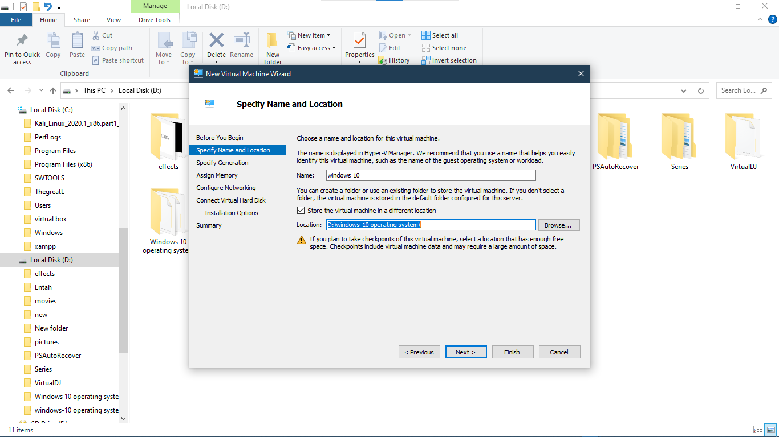
After click next you will be redirected to 'specify generation' section. Make sure the 'generation 1' radio button is selected and click next
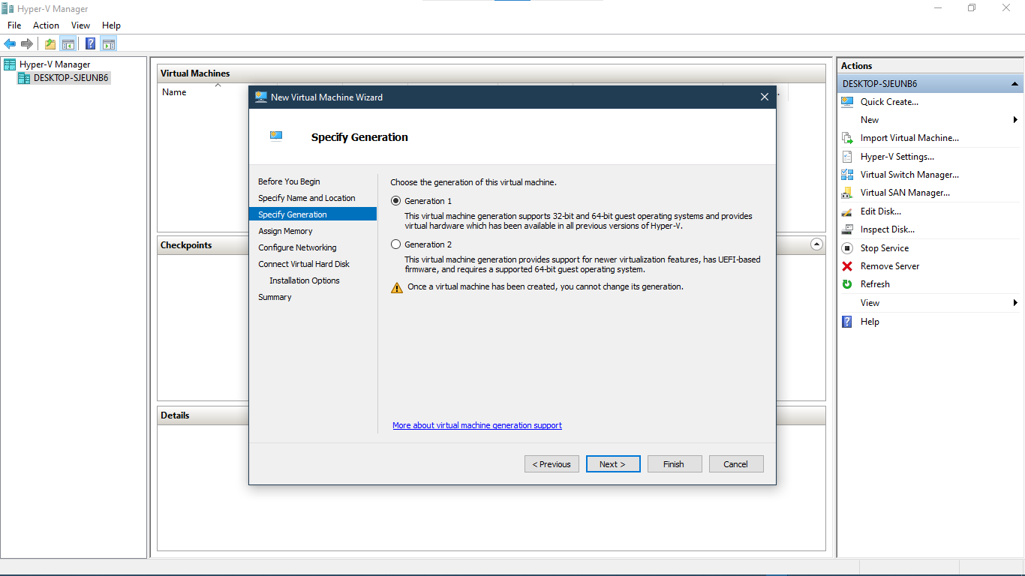
The 'assign memory' section will appear; enter your preferred startup memory and click next
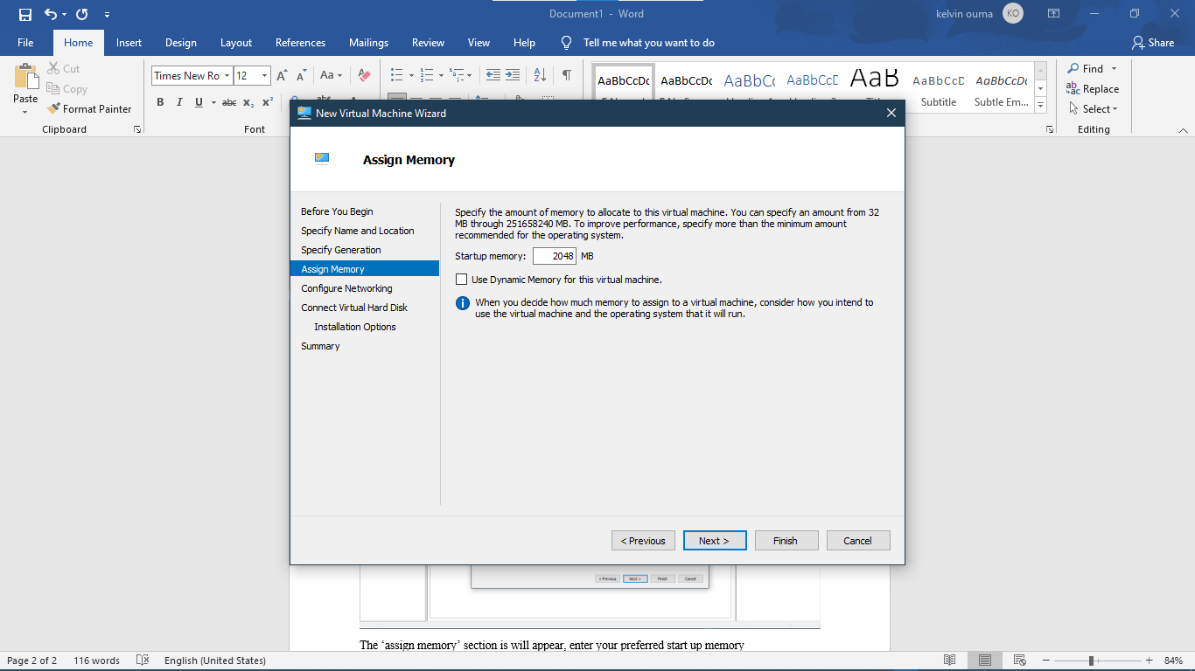
Check if it's connected; after configuring networking then by clicking next, you will be redirected to 'connect virtual hard disk option', enter the storage size and click next
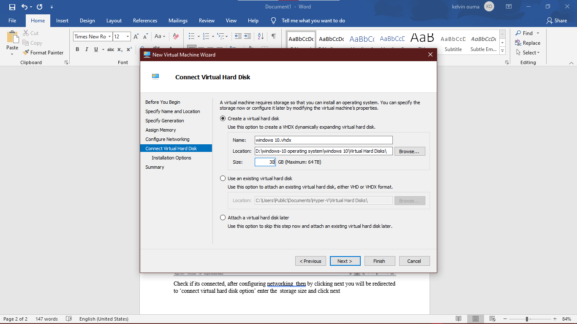
After being redirected to the 'installation options' section, check any radio button depending on where there is your operating system; for our case, we will check 'install an operating system from a bootable CD/ROM,' then check on 'image file' and then browse your image location where the operating image is located, click next to check the summary then finish
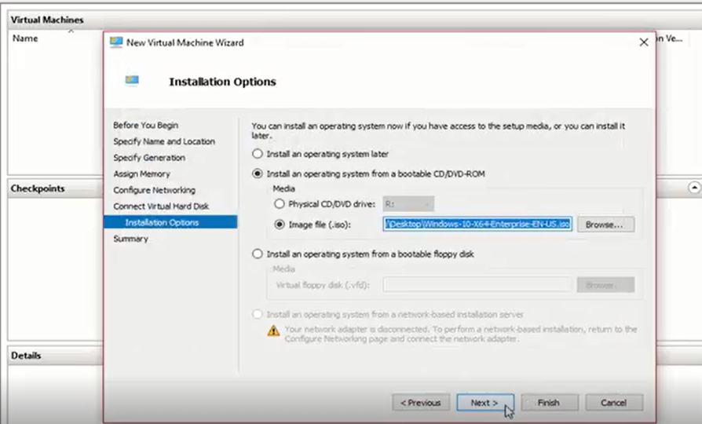
Select the operating system, then click 'connect'; after that, turn on the virtual machine. Enter your language and your preferred keyboard, then click next

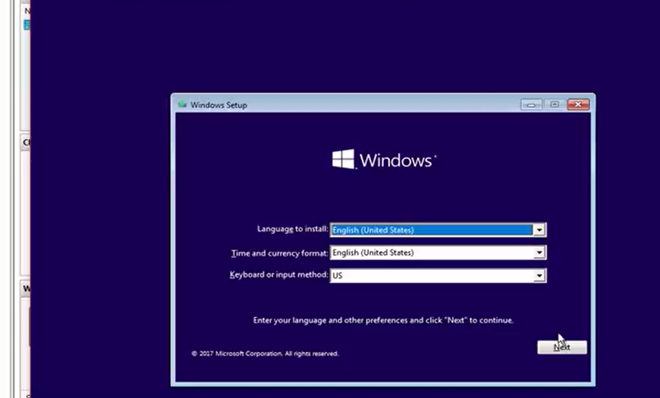
Click install now to install windows to your virtual machine, accept the license terms, click next to select the allocated space
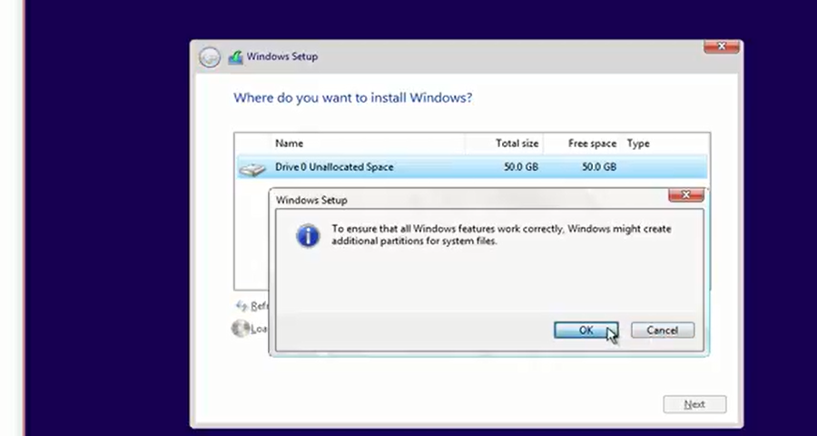
Once it has been allocated the space, it will install your windows on your virtual machine. you will be required to input your credentials like username and password, time zone, and location; after finishing this step, your windows 10 will be ready to use in your virtual machine

- Troubleshooting

When Hyper-V virtual machine fails to start, one is recommended to check the event log.

6.0 Glossary
Address: refers to the guest virtual address-spaces using the second level addressing translation.

CPU: This is an abbreviation of the central processing unit. CPU is found on the computer's motherboard.

Dynamic Memory: This is a feature in Microsoft Hyper-V which holds the host memory and transfers resources to virtual machines needing it. This memory provides an extra amount of memory needed for buffering.

Hyper-V: A native Hypervisor that creates virtualization on windows 10 machines of x86-64 system type

OS: This is an abbreviation of the operating system.

Operating system: Operating System is the management system software for hardware, software, and provision of a single serving of computer applications.

7.0 Reference List
Hong C, Spence. (2017) GPU virtualization and scheduling methods, ACM Computer surveys 1-30.
Windows virtual pc. (2018) "docs.microsoft.com/introduction to Hyper-V."

